

**PACE of Rhode Island Dashboard User Guide**

Contents

Overview 3

Landing Page 3

Create Password Page 4

Login Page 5

Navigation 6

Indicator Card Definitions 6

Cards 7

Basic Dashboard Page 8

Basic Chart Page 9

EDA Pages 10

Enrollment EDA 11

Demographics EDA 12

Incidents EDA 13

Utilization EDA 14

Participants by Town Page 15

Map of Participants Page 16

Additional Chart Options 17

# Overview

The PACE-RI internal dashboard is only accessible with a username and password and when the user is connected to the private PACE internal network. Usernames are controlled by the Data Analyst, if you believe you should have access to the dashboard please contact your manager or supervisor.

After logging in the main pages of the dashboard can be accessed via the links at the top of each page.

The dashboard is located at <http://internal.pace.dashboard:8041>

***Note:*** While the dashboard will *work* in Internet Explorer, Google Chrome is the preferred browser, so please use it!

# Landing Page

This is the first page you will see, if you already have set up your account click login, otherwise click “Create Password” if you have forgotten your password, click “Forgot Password” to send an email to the Data Analyst requesting a reset.

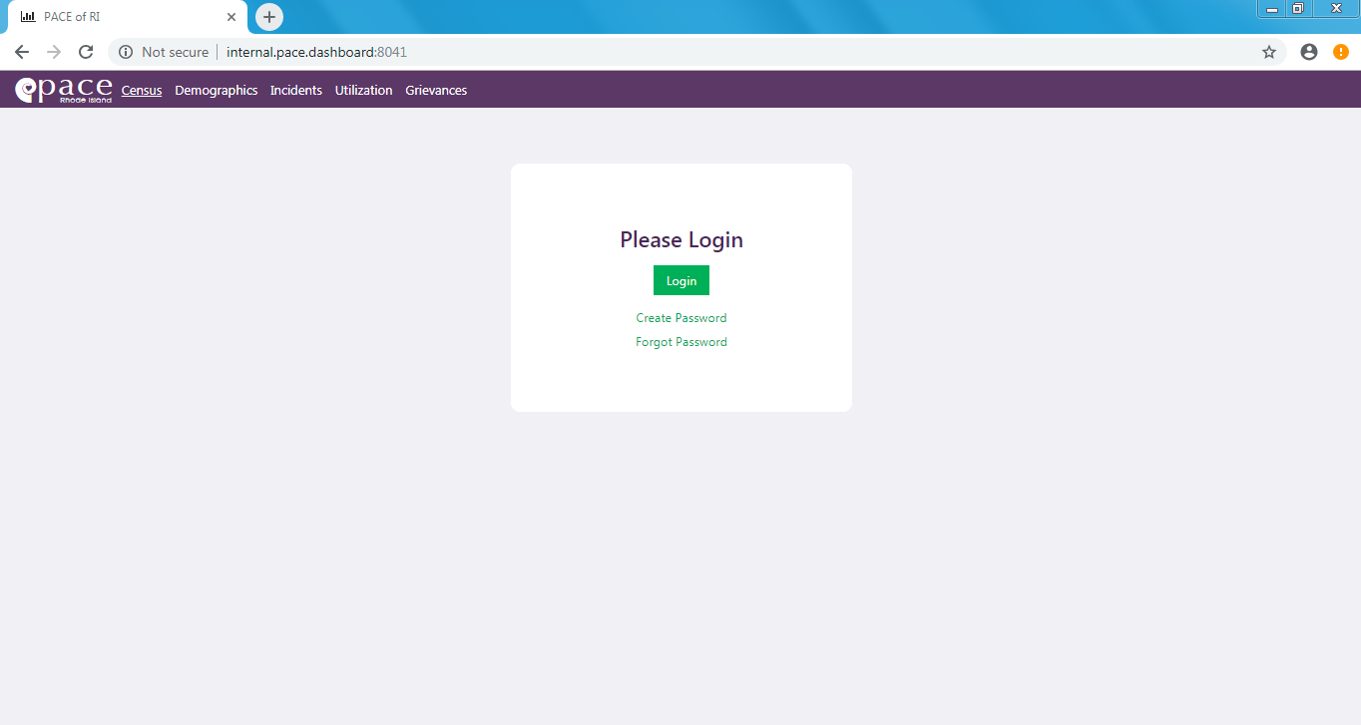

This link will take you to the “Create Password” page.

Press this button to reset your password if you forgot it. It will open a new Outlook message to the Data Analyst with the subject “Forgot Password.”

Press this button to enter the Login Page.

# Create Password Page

If this is your first time accessing the dashboard you will need to create a password. As stated above your username is already in the system. Your username is the same as your PACE email username. I.e. if your PACE email address is [hsimpson@pace-ri.org](mailto:hsimpson@pace-ri.org), then your username is simply *hsimpson*.

***Note:*** Your password must be *at least* **8** characters long, and include an **uppercase** letter, **2** numbers, and a **special character** (!?, etc.)

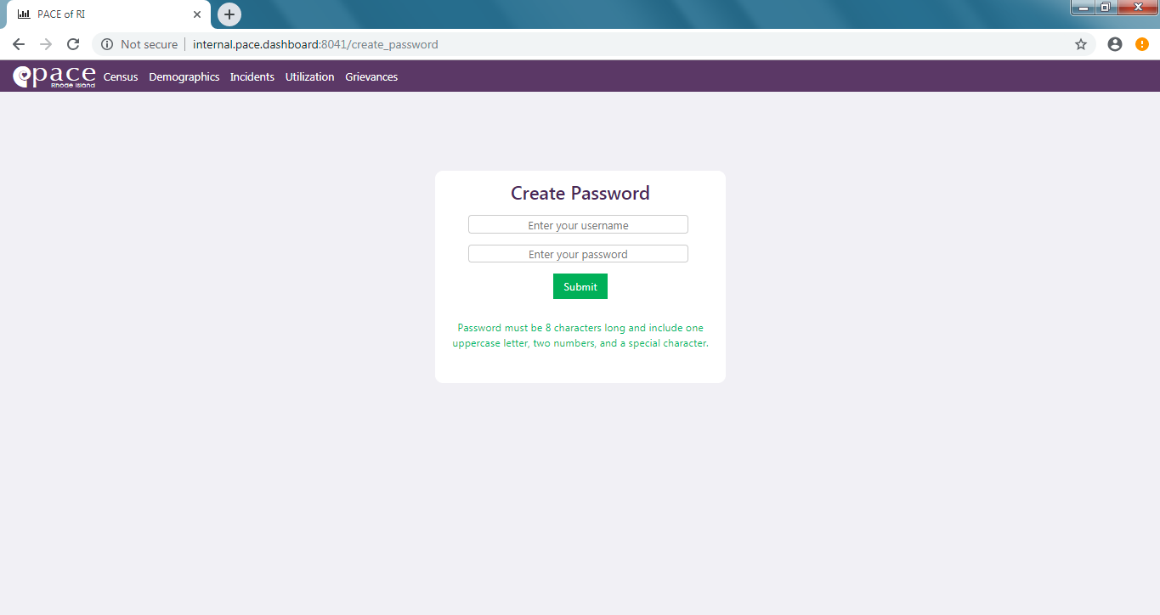

Enter your username in this box. Your username is the same as your PACE email username.

Enter the password you will use for the dashboard.

Press this button to submit your username and password.

***Note:*** After you submit your password and it accepted the green text at the bottom of the box will change. This new text is a link to the login page, click it to continue logging into the dashboard.

# Login Page

Clicking the *Login* button on the landing page will take you to this Login Page.

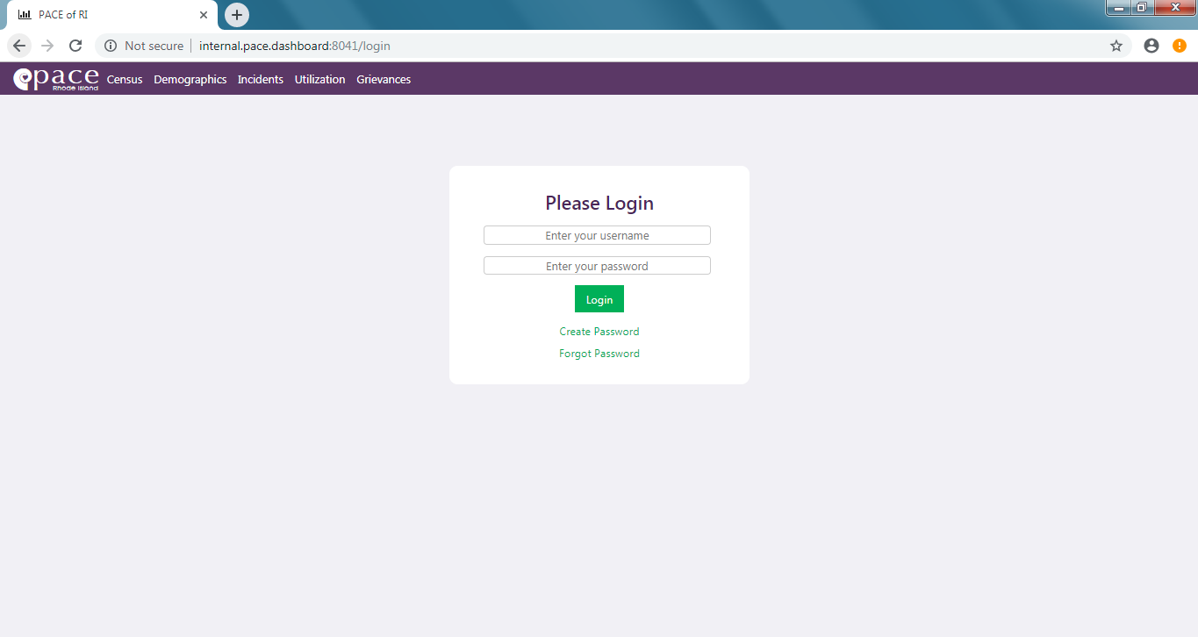

Press this button to login to the dashboard.

Enter the password that you created for your username on the “Create Password” screen.

This link will take you to the “Create Password” page.

Press this button to reset your password if you forgot it. It will open a new Outlook message to the Data Analyst with the subject “Forgot Password.”

Enter your username in this box. Your username is the same as your PACE email username.

# Navigation



This link will log you out of the dashboard when you are finished using it.

These are links to the main dashboard pages. Each page has data about specific aspects of PACE.

Clicking the PACE logo will take you to the Enrollment page which is the default page of the dashboard.

Each link on the navbar corresponds to a page of cards. These pages have a first row containing a page title and 4 radio buttons. These radio buttons indicate the time period for the values displayed in the cards. These radio buttons are grouped so that only one can be selected at a time.

***Note:*** *The Utilization page has links in its first row to the pages of two different type of inpatient stays (inpatient/nursing facility). It defaults to Inpatient/ER*

# Indicator Card Definitions

The included [Dashboard Page](Dashboard%20Page%20Definitions.xlsx) Definitions Excel workbook contains a sheet for each dashboard page. Each sheet lists what indicators appear on the page, the definition for the indicator and the ***paceutils*** function used to calculate the value.

# Cards

Each card is titled with the represented indicator and contains;

* the value of the indicator for the selected time period.
* an arrow comparing the value to the previous time period’s value for the indicator.
  + If month to date is selected it is compared to the last month. If last month is selected it is compared to the month prior. This works the same way for quarters.
* a sparkline graph.

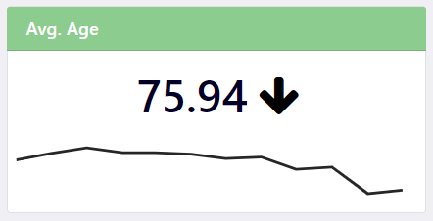

Arrow indicating if the current indicator value is above, below, or equal to the indicator’s value in the previous time period.

Sparkline showing the trend of this indicator over the past year.

Name of the indicator.

Indicator value for selected time period. Links to a page with a large version of the sparkline graph.

# Basic Dashboard Page

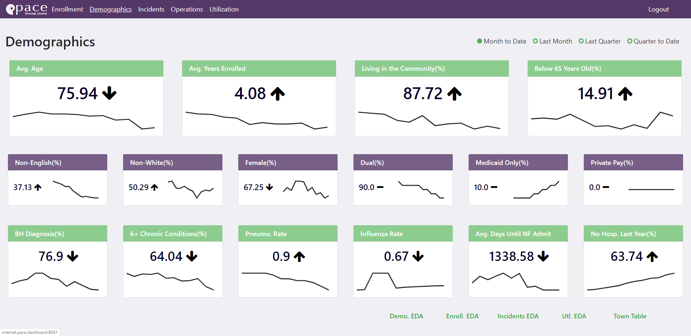

These are links to “EDA” or Exploratory Analysis pages. These are versions of pages from the first iteration of the dashboard. They provide the user additional abilities to slice, filter, and view the data.

# Basic Chart Page

Clicking any of the indicator values in a card will open a new page with a larger version of the graph. On this page the graph can be further filtered by date or grouped by month or quarter. The data for the graph can also be downloaded as a CSV file.

These are links to “EDA” or Exploratory Analysis pages. These are versions of pages from the first iteration of the dashboard. They provide the user additional abilities to slice, filter, and view the data.

Allows user to download a csv file of the data – is of the format date/value.

Filter data by dates – defaults to the last year.

Group data by month or quarter.

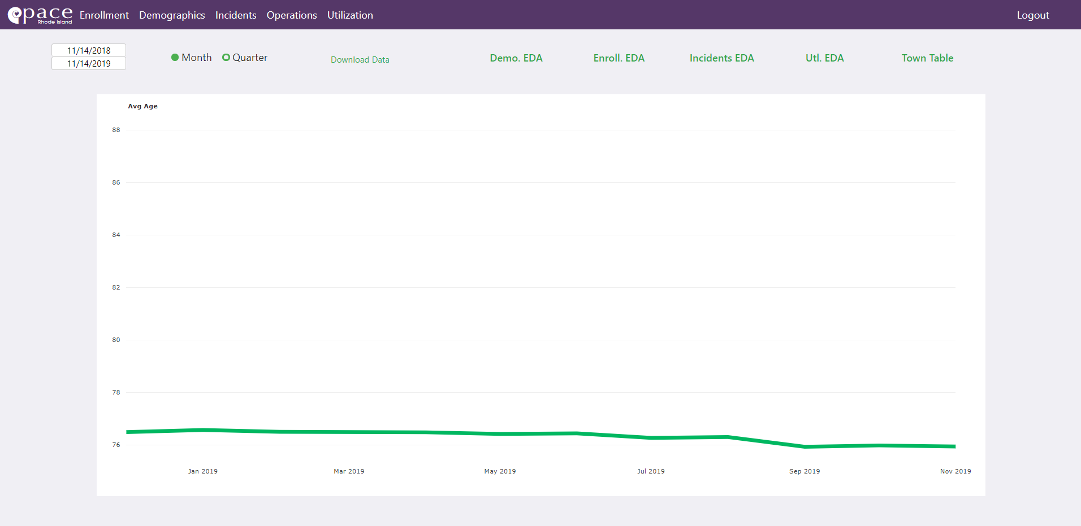

# EDA Pages

These are pages that give the users additional filter options to slice and visualize the related data. Useful for looking at more specific filters or trends – not as useful for viewing single data points.

These EDA pages all have the following filters.

A dropdown to filter the data by center, options are All Centers, Providence, Woonsocket, and Westerly



Fields to filter the data by date. The top field is for the start date of the period and the bottom field is the end date of the period.

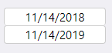

A radio button to group the graph by month or quarter.

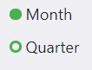

## Enrollment EDA

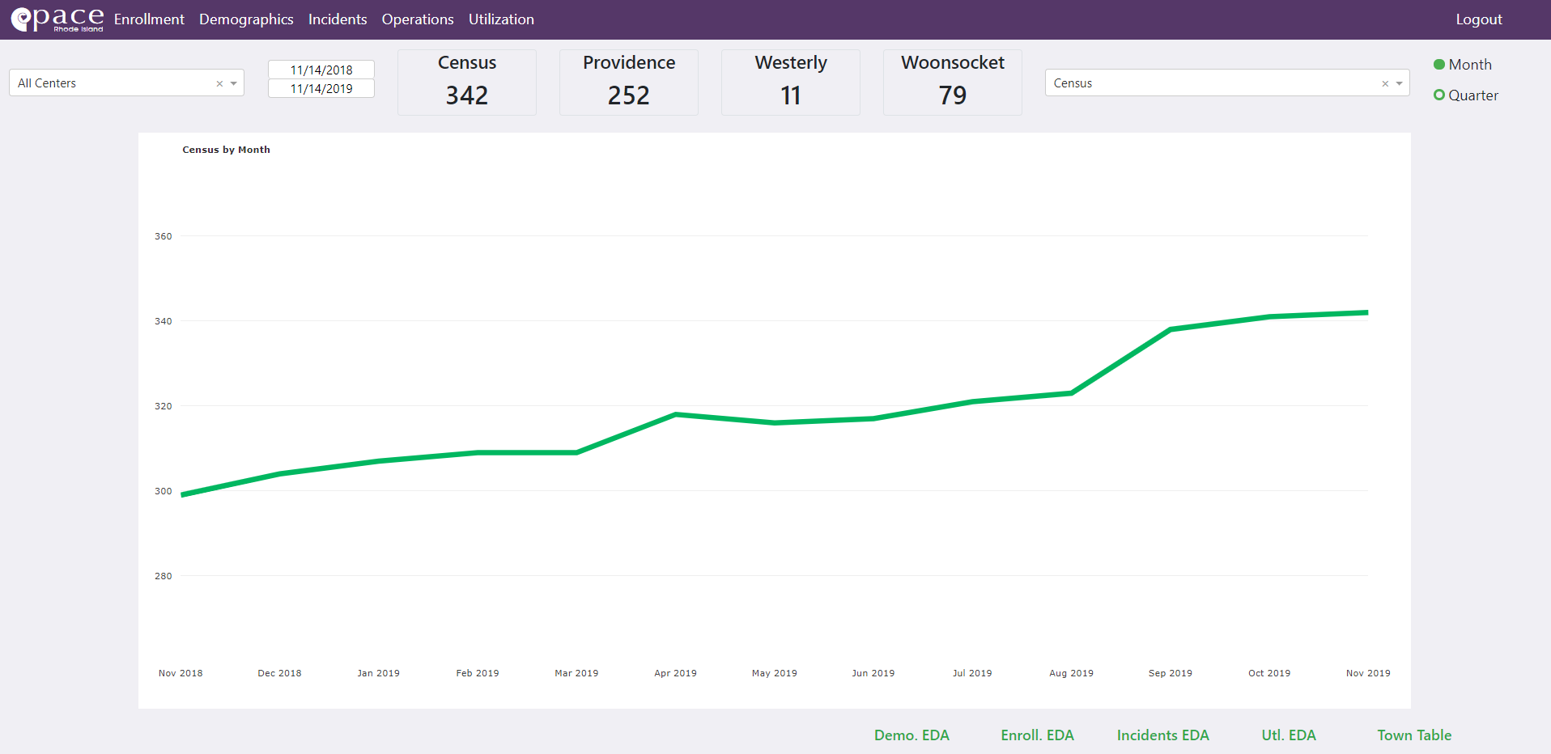

The top dropdown will change the content in the graph.

These boxes contain the census as of the day you are looking at the dashboard for all of PACE of Rhode Island and each center.

## Demographics EDA

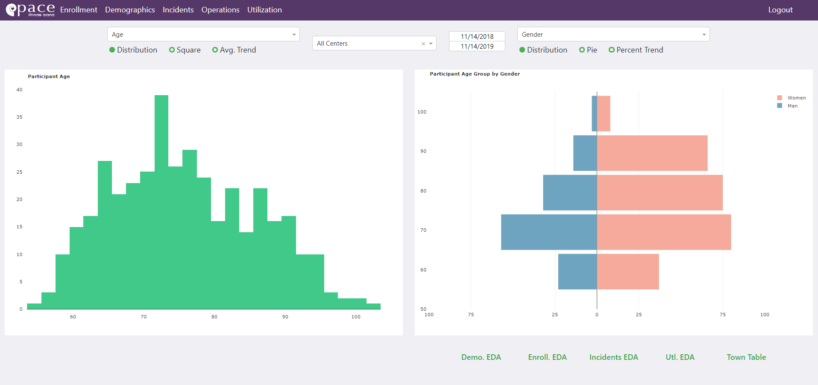

Changes the content of the left graph.

Changes the content of the right graph.

These radio buttons change based on the dropdown option chosen. They change the chart type and the way the content is displayed.

## Incidents EDA

This page displays data about different incidents related to PACE of RI ppts, the screen capture below displays the Falls page.

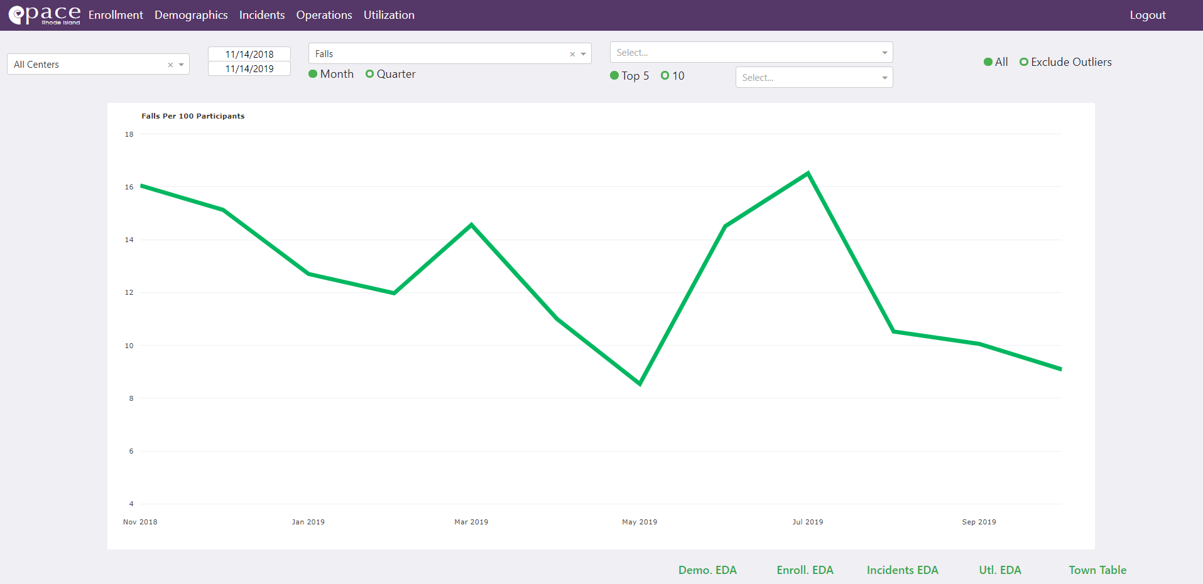

Dropdown will change the incident data source used. Options are Falls, Med Errors, Wounds, Burns, and Infections.

Use this dropdown to see a specific aspect of the topic in the graph. You can select the top 5 or top 10 data points or you can search through specific options using the dropdown on the right.

Press the button to specify whether you want to look at all data associated with your options or data that excludes outliers. (outlier definition explained below)

When a specific aspect of the indecent report is selected in the dropdown, this chart will become a bar graph of the percent of incidents in each period attributed to each value in the selected aspect column.

## Utilization EDA

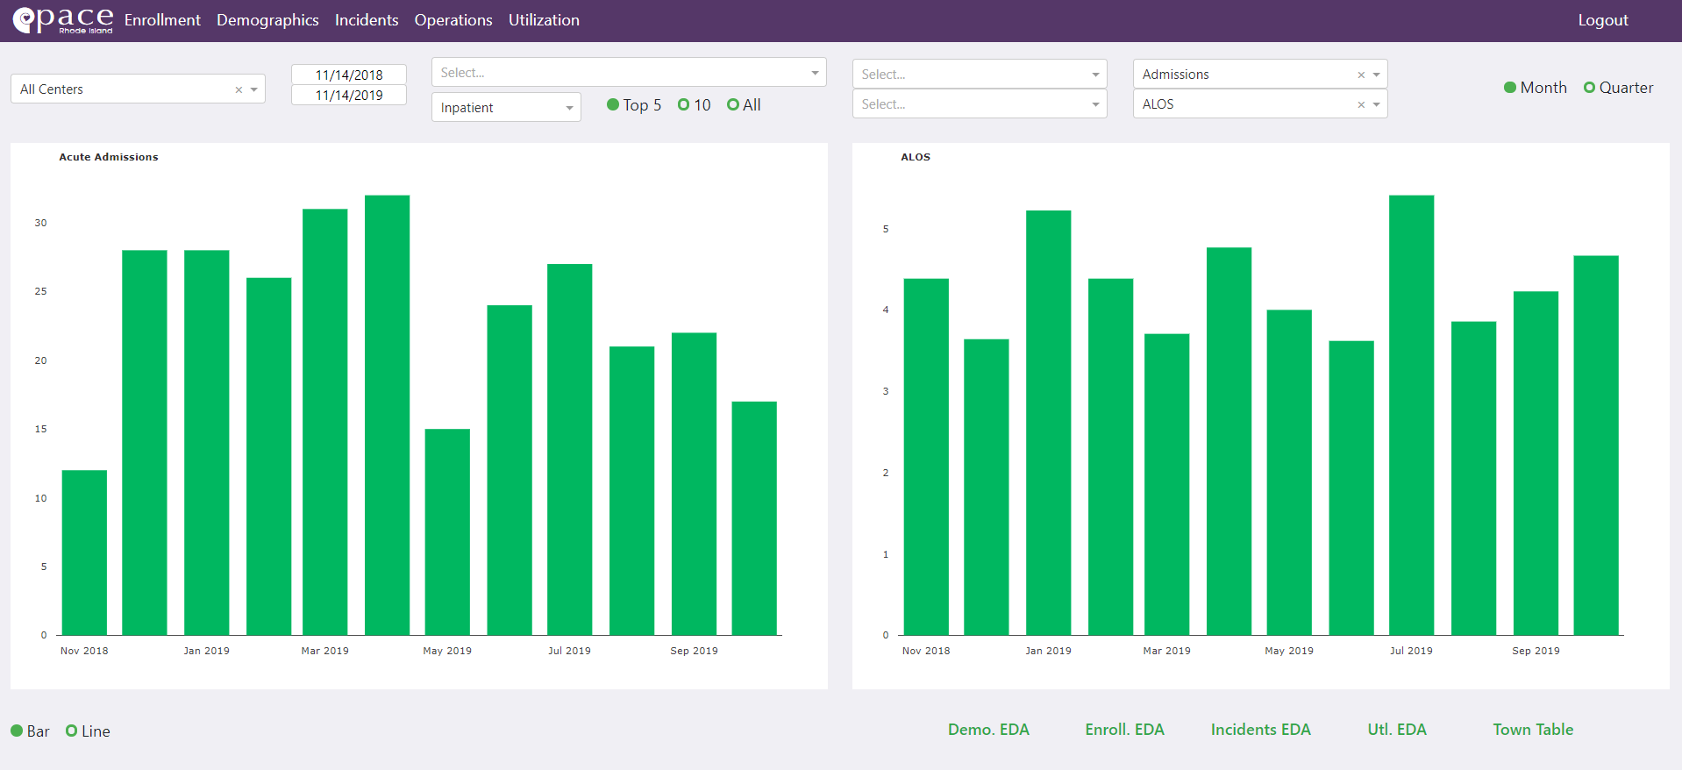

Use this Dropdown to look at a specific aspect of the utilization data; all options specified below.

Use this dropdown to change the utilization data type for the page. Options are: Inpatient, Inpatient-Psych, ER only, Skilled, Custodial, or Respite.

Click the button to specify whether you want to look at to top 5, top 10, or all data points for the option specified in the above dropdown menu.

Use this dropdown to pick a detailed reason/input associated with the dropdown on the left. Each option/aspect has a different set of reasons and inputs.

Use this dropdown to further filter the utilization data, options include the time, day of the week, and others. All options are specified below.

The top dropdown will change the content of the left graph and the bottom will change the right graph. Options are Admissions, Discharges, ALOS, and 30-Day Readmits.

Changes both graphs to a line graph or bar graph.

## Participants by Town Page

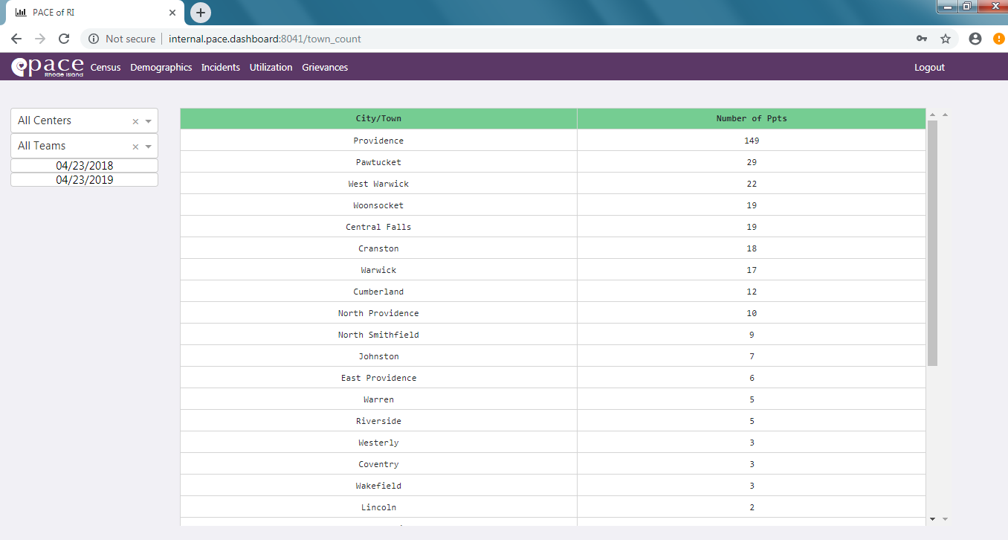This page shows the counts of participants by town of residence.

## Map of Participants Page

*How to use the map*: Click and Drag the map to move the map around. Scroll up to zoom in on the graph. Scroll down to zoom out on the graph. Download and reset axes buttons have the same icon and function as the graph options outlined at the end of this guide.

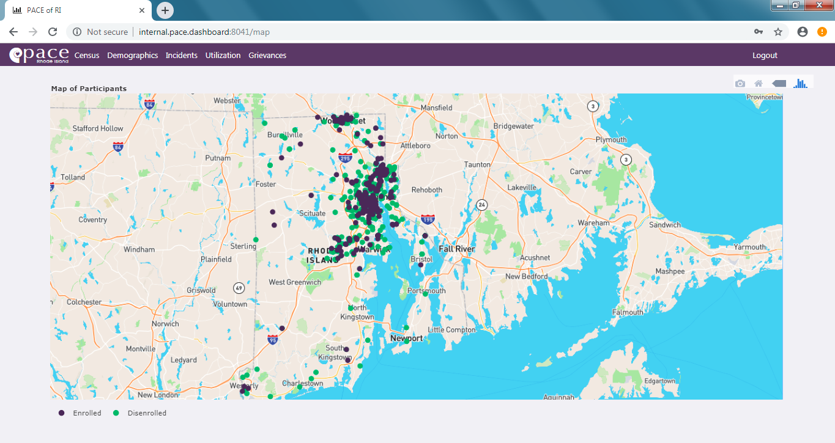

Press this button to show data about the closest point when you hover over the graph. You can toggle this option on and off when you press this button.

By clicking these points, they can be toggled on and off the map.

# Additional Chart Options

These options appear when you scroll your mouse over any graph in the dashboard, and these can change the view settings of the chart and give you the ability to download the chart. You can also hover over the charts for more information.

Press this button to zoom in on the graph.

Press this button to reset the axes of the graph if you altered them from zooming in or out.

Press this button to download the plot you are looking at as an SVG file.

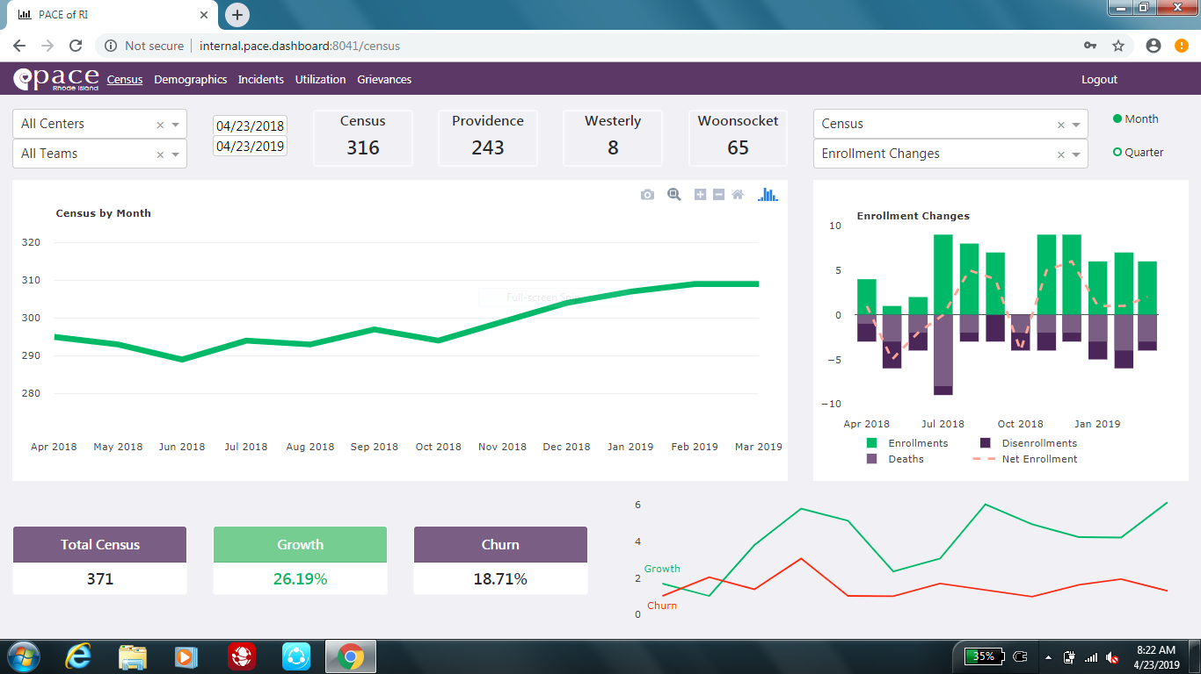

This will take you to plotly’s website, this is a library for plotting data using python.

When you press this button, it gives you the ability to drag your mouse through a certain section of the chart, and the chart automatically zooms in on that section of the chart.

Press this button to zoom out on the graph.